8.1.5 Editors - Image Editor - Header - Mask menu
Image Editor - Mask menu 2
Delete 2
Duplicate 2
Toggle Cyclic 2
Switch Direction 2
Recalc Normals 2
Set Handle Type 2
Last Operator Set Handle Type 2
Type 2
Clear Parent 3
Make Parent 3
Copy Splines 3
Paste Splines 3
Show/Hide 3
Show/Hide Faces 3
Show Hidden 3
Hide Selected 3
Hide Unselected 3
Transform 3
Translate 3
Rotate 3
Scale 4
Scale Feather 4
Clear Feather Weight 4
Animation 4
Insert Shape Key 4
Clear Shape Key 4
Feather Reset Animation 4
Re-Key Points of Selected Shapes 4

Image Editor - Mask menu

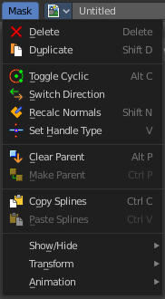
This menu appears when you are in Mask mode. It contains further functionality to modify the masking spline curves.

Delete
Deletes the selected spline(s) or spline points.

Duplicate
Deletes the selected spline(s) or spline points.

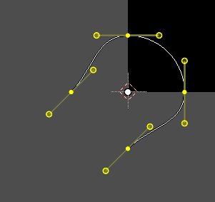
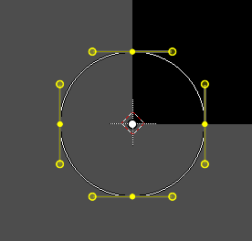
Toggle Cyclic
Closes or opens the spline.

Switch Direction
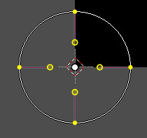
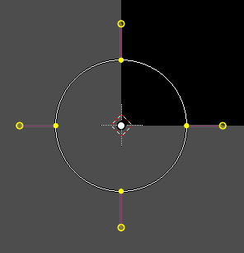
A curve has a start point and a end point. Here you can switch them. The end point becomes the starting point and vice versa. As a consequence the handler can switch their location too. With handle type aligned single they can appear outside or inside of the circle.

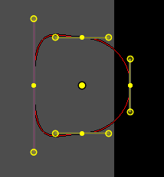
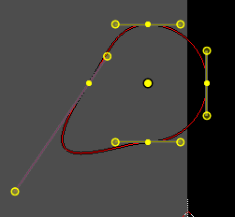
Recalc Normals
Recalculating the normals smoothens out the curve, and realigns the handlers. A square shape with handle type aligned would becomre round.

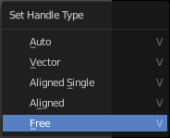
Set Handle Type
Opens a sub menu where you can choose different handle types.

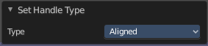
Last Operator Set Handle Type

Type
Here you can choose the handle type again.

Clear Parent
Clears the parent relationship.

Make Parent
Parents the selected spline points. Mask splines can be parented to motion tracker markers.

Copy Splines
Copys the selected spline(s) or spline points.

Paste Splines
Pastes the copied spline(s) or spline points.

Show/Hide

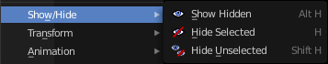
Show/Hide Faces
This is a sub menu where you can show or hide the selection.

Show Hidden
Makes hidden splines visible again.

Hide Selected
Hides the selected spline(s).

Hide Unselected
Hides the not selected spline(s). The selected spline(s) stays visible.

Transform
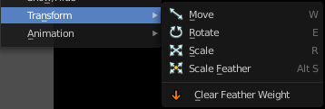
This is a sub menu with some transform menu items. This menu items are hotkey tools!

Translate
Move the selection.

Rotate
Rotate the selection.

Scale
Scale the selection.

Scale Feather
Shrinkfattens the selection.

Clear Feather Weight
Resets the scale to its original dimensions.

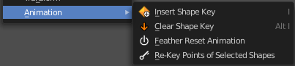
Animation
Masks can be animated.

Insert Shape Key
Inserts a shape key for the currently selected curve points

Clear Shape Key
Removes the shape keys for the currently selected curve points at the current frame.

Feather Reset Animation
Resets the feather weight on all selected curve points at the current frame.

Re-Key Points of Selected Shapes
Recalculate animation data for the currently selected curve points for frames that are selected in the dopesheet.

